In this lab, we'll delve into hypothesis space complexity, explore its impact on model performance, and experiment with different levels of complexity to gain a deeper understanding of its role in machine learning.

**Hypothesis Space Complexity**

In machine learning, the **hypothesis space** refers to the set of all possible models or functions that a learning algorithm can use to approximate the true relationship between the input features and the target variable. The hypothesis space is a crucial concept as it defines the capacity or complexity of the model that the algorithm can choose from to make predictions.

The hypothesis space **complexity** is a measure of the richness or intricacy of this set of models.

*A higher complexity means a larger, more intricate hypothesis space, allowing for a greater variety of potential models. Conversely, a lower complexity implies a more constrained hypothesis space with simpler models.*

Understanding and managing hypothesis space complexity is vital in machine learning, as it directly impacts how well a model can learn and generalize from the training data to unseen data.

**Key Points**

* Hypothesis Space: The set of possible models or functions that a machine learning algorithm considers to represent the relationship between input features and the target variable.
* Hypothesis Space Complexity: The level of complexity or intricacy of the hypothesis space, determined by the variety and richness of models it can represent.
* Impact on Learning: The complexity of the hypothesis space affects how well a model can capture the underlying patterns in the data. A too simple hypothesis space may fail to capture complex relationships, while an overly complex space can lead to overfitting.
* Balancing Complexity: Striking the right balance in hypothesis space complexity is crucial. A model should be complex enough to capture essential patterns but not so complex that it overfits the training data and performs poorly on unseen data.

Let's demonstrate how to experiment with hypothesis space complexity using Python. We'll create simple and complex hypothesis spaces for a linear regression problem.

Let's run this code in your notebook!

import numpy as np

import matplotlib.pyplot as plt

# Generate some example data

np.random.seed(0)

X = 2 * np.random.rand(100, 1)

y = 3 * X + np.random.randn(100, 1)

# Simple Hypothesis Space (e.g., linear model)

def simple_hypothesis(X, theta0, theta1):

return theta0 + theta1 * X

# Complex Hypothesis Space (e.g., high-degree polynomial)

def complex_hypothesis(X, theta):

# Using a 9th-degree polynomial

return np.sum(theta[i] * X**i for i in range(len(theta)))

# Fit the models

theta_simple = np.polyfit(X.flatten(), y.flatten(), 1)

theta_complex = np.polyfit(X.flatten(), y.flatten(), 9)

# Generate predictions

X_test = np.linspace(0, 2, 100).reshape(-1, 1)

y_simple = simple_hypothesis(X_test, theta_simple[1], theta_simple[0])

y_complex = complex_hypothesis(X_test, theta_complex)

# Plot the data and models

plt.figure(figsize=(10, 6))

plt.scatter(X, y, label='Data')

plt.plot(X_test, y_simple, label='Simple Hypothesis Space (Linear)')

plt.plot(X_test, y_complex, label='Complex Hypothesis Space (9th-degree Polynomial)')

plt.xlabel('X')

plt.ylabel('y')

plt.legend()

plt.title('Simple vs. Complex Hypothesis Space')

plt.show()

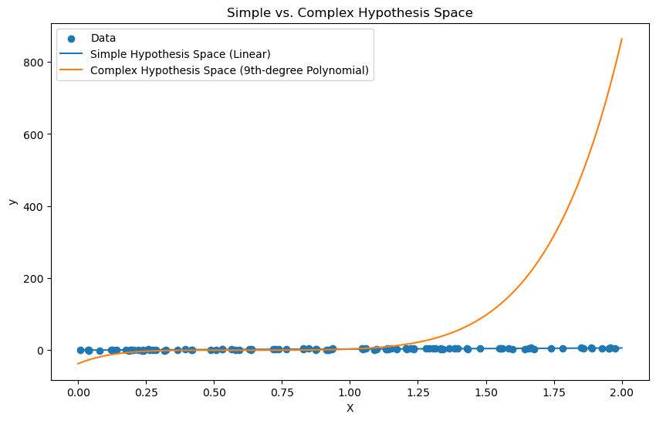

Preview

Example

Let's demonstrate hypothesis space complexity using a classification problem with a simple and complex hypothesis space.

*Do not worry about all the concept of the code, you will learn in the next track.*

import numpy as np

import matplotlib.pyplot as plt

from sklearn.datasets import make_classification

from sklearn.linear_model import LogisticRegression

from sklearn.preprocessing import PolynomialFeatures

from sklearn.pipeline import make_pipeline

# Generate a synthetic dataset for binary classification

X, y = make_classification(n_samples=100, n_features=1, n_informative=1, n_redundant=0, n_clusters_per_class=1, random_state=42)

# Simple Hypothesis Space (Linear)

model_simple = LogisticRegression()

model_simple.fit(X, y)

# Complex Hypothesis Space (Polynomial)

model_complex = make_pipeline(PolynomialFeatures(10), LogisticRegression())

model_complex.fit(X, y)

# Generate a range of X values for plotting

X_plot = np.linspace(X.min(), X.max(), 300).reshape(-1, 1)

# Predictions

y_pred_simple = model_simple.predict_proba(X_plot)[:, 1]

y_pred_complex = model_complex.predict_proba(X_plot)[:, 1]

# Plot the data and decision boundaries

plt.figure(figsize=(10, 6))

plt.scatter(X, y, color='blue', label='Data')

plt.plot(X_plot, y_pred_simple, color='green', label='Simple Hypothesis (Linear)')

plt.plot(X_plot, y_pred_complex, color='red', label='Complex Hypothesis (Polynomial)')

plt.xlabel('X')

plt.ylabel('y')

plt.legend()

plt.title('Simple vs. Complex Hypothesis Space for Classification')

plt.show()

This code demonstrates a simple and complex hypothesis space for a classification problem, showing how hypothesis space complexity affects model representation. Feel free to experiment with different hypothesis spaces and observe the results!

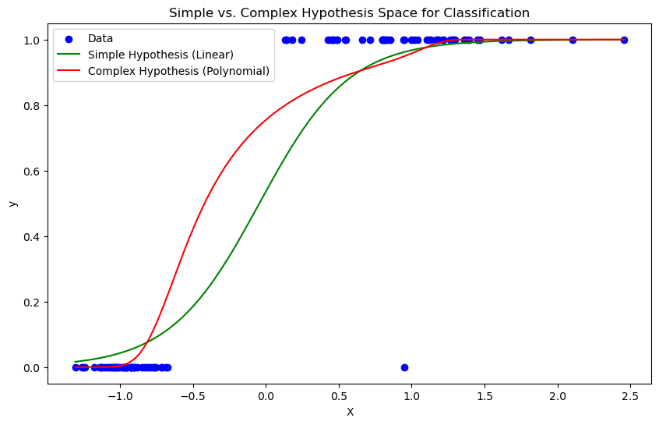

Preview

Quiz

1

**True or False: A larger hypothesis space always leads to better model performance.**

False

True

SubmittedCorrect!

Start project before checking your activities.

2

**True or False: Overfitting occurs when the hypothesis space is too complex for the given data.**

True

False

SubmittedCorrect!

Start project before checking your activities.

3

**Scenario Question**

You are a data scientist working on a binary classification problem. You have tried two different models for the task. Model A uses a simple hypothesis space with a linear model, while Model B employs a more complex hypothesis space with a high-degree polynomial. After evaluating both models, you notice that Model B fits the training data almost perfectly, but its performance on new, unseen data is not as good. On the other hand, Model A generalizes better to unseen data.

Based on this scenario, which model is likely suffering from overfitting?

Model B, because it fits the training data almost perfectly.

Both models are suffering from overfitting.

Neither model is suffering from overfitting.

Model A, because it uses a linear hypothesis space.

SubmittedCorrect!